



Big River

Version # 1.00

Friday, July 31, 2026

Contents

Game Overview 1
Philosophy 3
Player Role 3
Player Goals 3
Feature Set 4
General Features 4
Rendering System 4
Sound Design 4
GamePlay 4

Design History

This section tracks the design versions of BIG RIVER.

Version 1.01(Current)

Version 1.01 revises the game world, features, and player tools, including:

- Clarification of level advances
- Output for player decisions
3. Removal of stop and start mechanisms on the river

Game Overview

Philosophy

BIG RIVER is a simple single-player strategy game similar to Vectoid or other tower defense simulations. Players are given the management of a river. Their decisions about the use of the river determine the water resources available to a town.

Values
- Conservation
- Sustainability

Player Goals

The player’s goal is to use the inventory icons to keep the town’s water supply constant and to avoid droughts, or floods for a set period of time (ex. two minutes).

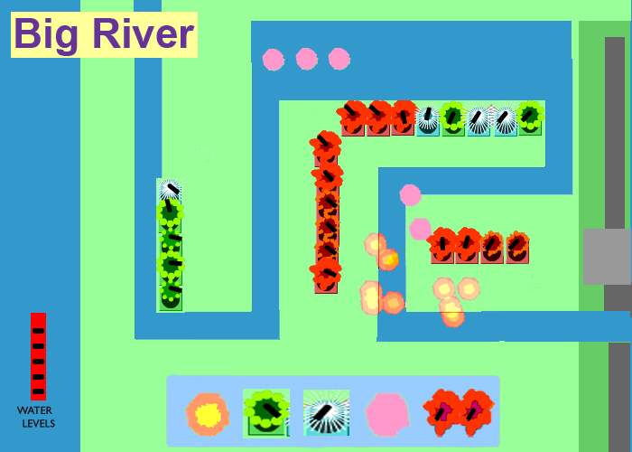

Feature Set

General Features
Inventory Panel
Inventory Icons
River
Town
Icons that illustrate good or bad river management

Rendering System
Flash 2D Animation

Sound Design
Arcade sound effects

Gameplay

The river flows throughout the game., The player drags icons of factories, power plants, car washes, etc from the inventory panel up to the main screen of a riverbed set into a grid. As the player arranges these icons, the level of the river rises or falls and, depending on the arrangement of inventory icons, the town receives too much or too little water. The game responds to the players management of resources by showing progress on a water meter. The river itself responds with fun and surprising icons. For example, well-balanced river might respond with happy fish jumping out of the water. A river that is running wild might show townspeople surfing on big waves, etc. As levels advance and players are asked to deal with more complex problems of water management such as pollution, fish with x’s over their eyes may jump out of the river as a surprise to players.

