



Fingerprint

Version # 1.00

Wednesday, July 29, 2026

Contents

Game Overview 1
Philosophy 3
Player Role 3
Player Goals 3
Feature Set 4
General Features 4
Rendering System 4
Sound Design 4
GamePlay 4

Design History

This section tracks the design versions of FINGERPRINT.

Version 1.01(Current)

Version 1.01 is a revised description of the game, including
- strategy for getting out of the maze
- timers for measuring response to IAT icons that measure unacknowledged racial biases
- Information screens that offer the player more data on inequities of the justice system

Game Overview

Philosophy

FINGERPRINT is a simple maze game that illustrates well-documented racial inequalities in the criminal justice system. Players choose a black, brown, yellow, or white fingerprint and, starting in the center of the whorl, try to maneuver their way out of the maze. During this, the player encounters obstacles or puzzles that represent the racial bias in the legal system.

Values
Equality
Justice

Player Goals

The player’s goal is to escape the maze.

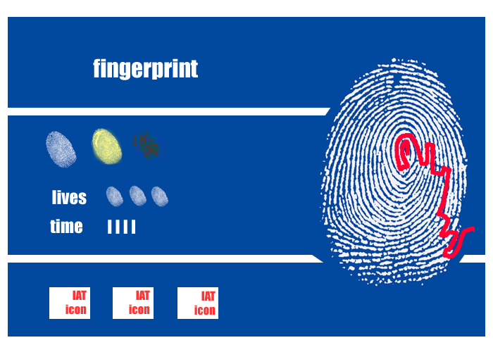

Feature Set

General Features
Print selection screen
Fingerprint maze
Player Token
IAT icons
Data screens

Rendering System
Flash 2D Animation

Sound Design
Arcade sound effects

Gameplay

On the print selection screen, the player chooses a black, brown, yellow, or white fingerprint. The chosen print expands to fill the game screen and, at this level of zoom, reveals itself as a maze. The player token is at the center of the maze.
Using her mouse, the player guides her token through the maze to the exit point at the edge of the fingerprint. Along the way, she encounters puzzle obstacles that illustrate racial biases within the legal system. In some parts of the puzzle, the maze may change dynamically in ways that oppose the player’s moves. For instance, within the maze of the black print, the player may find that certain paths in the maze initially appear to be open but close themselves off once she enters them. The longer the player stays in the brown maze, the harder it may be to find a way out. In the white maze, shortcuts are likely to appear. As players become more familiar with the advantage and disadvantages of particular mazes, they can plan their routes through a fingerprint accordingly. The goal is to get through the fingerprint maze as quickly as possible.
Along the bottom of the screen the player can choose from a set of IAT icons that measure the player’s response time to icons that prompt racial biases.
At the end of the maze players have the option to view information screens that provide more data on inequalities within the justice system.

