



The Layoff Game

Version # 1.00

Wednesday, July 29, 2026

Contents

Game Overview 1
Philosophy 3
Player Role 3
Player Goals 3
Feature Set 4
General Features 4
Rendering System 4
Sound Design 4
GamePlay 4

Design History

This section tracks the design versions of THE LAYOFF GAME.

Version 1.01(Current)

Version 1.01 is a revision of the game world, features, and player tools, including
- new title
- addition of job migration animation that suggests where the icons go when they are removed from the game grid

Game Overview

Philosophy

The Layoff Game is a puzzle arcade game that illustrates the elimination of certain wage sectors within the U.S. economy. While arcade games like Zookeeper and Bedazzled can be thought of as mods of Tetris, The Layoff Game can be considered a mod of Zookeeper. In order to solve the puzzle, players must eliminate certain types of workers.

Values
Unfairness in the labor market

Player Goals

The player’s goal is to manipulate worker icons into groups and to eliminate those groups until only two types of icons remain, fast food workers and CEO.

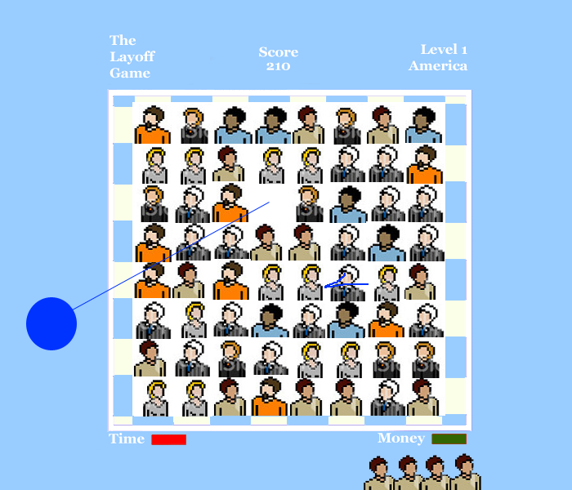

Feature Set

General Features
Worker Icons
Puzzle Grid
Job migration animation
Falling worker animation

Rendering System
Flash 2D Animation

Sound Design
Arcade sound effects

Gameplay

The game starts with worker icons arranged at random in a grid. When the player clicks on a character icon, it switches places with the icon beside it. As the player works to make matches, the game shows the amount of time and money that has elapsed. When the player is able to arrange three of the same icons in a row, for instance, three factory workers, these icons fall to the bottom of the screen and form a line of workers that move off the screen. Meanwhile, a pop-up icon of the world appears on the game grid, and a line is drawn from the icon’s old place on the grid to the place in the world where that worker’s job has been sent. Other worker icons fall or shift to rearrange the game grid as in Tetris. The icons that have been eliminated are replaced by two fast food worker icons and one CEO icon. The goal is to eliminate as many workers as possible before running out of time and money.
As the levels advance, the game grid represents different groups of workers in different parts of the world and the player follows job migration throughout several regions.

