



More More More

Version # 1.00

Friday, July 31, 2026

Contents

Game Overview 1
Philosophy 3
Player Role 3
Player Goals 3
Feature Set 4
General Features 4
Rendering System 4
Sound Design 4
GamePlay 4

Design History

This section tracks the design versions of MORE MORE MORE.

Version 1.01(Current)

Version 1.01 is revised description of the game, features, and player tools including
1. power up and power down dot

Game Overview

Philosophy

MORE MORE MORE is a Pac Man mod that models the problems of consumption.

Values
Sustainability

Player Goals

The player’s goal is to keep Pac Man at a manageable size and weight while navigating the dot maze.

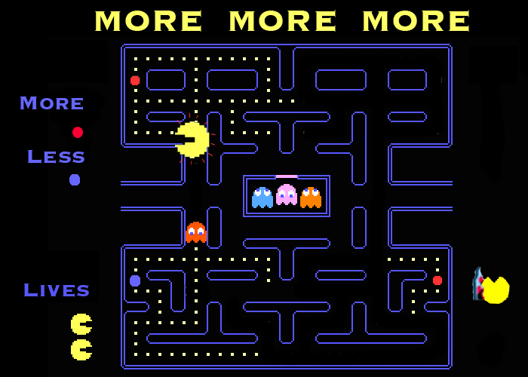

Feature Set

General Features
Pac Man
Dot Maze
Ghosts
Power up dots
Power down dots

Rendering System
Flash 2D Animation

Sound Design
Arcade sound effects

Gameplay

The gameplay in MORE MORE MORE intentionally mirrors the Pac Man arcade game, but in this version as Pac Man consumes, he gains weight, slows down and begins to have trouble moving. Players can us their power up and power down dots to try and avoid getting trapped, but if Pac Man consumes too much, before long he’ll hardly be able to wedge himself through the maze or avoid his arch enemies, the Ghosts. Pac Man squeaks when he gets too fat or gets stuck.

However, Pac Man can exercise by going to the outer ring of the MORE MORE MORE maze and tediously running back and forth until he loses weight. This should be boring, in other words, the player is sort of punished for consumption by having to play through some tedious levels.

