



Towers of the Empire

Version # 1.00

Tuesday, July 28, 2026

Contents

Game Overview 1
Philosophy 3
Player Role 3
Player Goals 3
Feature Set 4
General Features 4
Rendering System 4
Sound Design 4
GamePlay 4

Design History

This section tracks the design versions of TOWERS OF THE EMPIRE.

Version 1.01(Current)

Version 1.01 is revised description of the game, features, and player tools, including
- decreasing the autonomy of the colony player
- addition of colonial and empire npcs that move about the towers

Game Overview

Philosophy

TOWERS OF THE EMPIRE is a puzzle arcade game that illustrates the processes of colonialism through a mechanic of reciprocal destruction. The gameplay is modeled on the block game Jenga. This game can be multi-player.

Values
Colonialism

Player Goals

Players manipulate empire and colony blocks in two towers until, inevitably, one or both of these towers collapse.

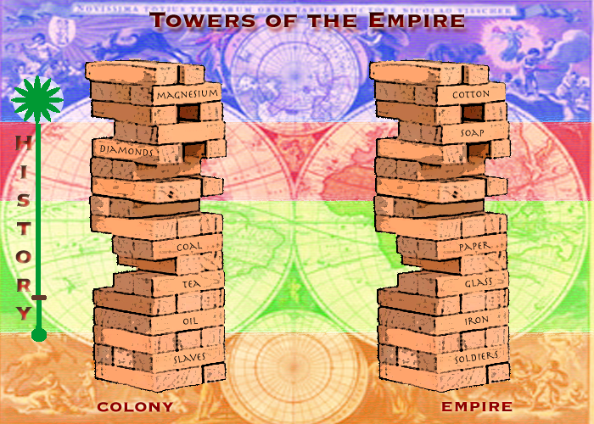

Feature Set

General Features
Moveable Jenga Blocks
Colony and Empire NPCs
History dial
Information screen

Rendering System
Flash 2D Animation

Sound Design
Arcade sound effects

Gameplay

At the start of the game the players are presented with two towers built of blocks. One tower represents the empire. Its blocks are labeled cloth, iron, the Bible, and so on in representation of the typical exports of imperialism. In higher levels of the game, blocks might include, debt, seeds, etc.
The second tower represents the colony. Its blocks are labels slaves, workers, oil, magnesium, etc.
The player can control the context of the exchange between empire and colony by using the info buttons to set the year in which each game takes place,
Certain blocks may be weighted so that their removal would have a greater destabilizing effect of the tower than one of the other blocks, that is, removing oil might be more damaging to the colony than removing salt, just as removing the delusional self-image block from the empire tower might be more damaging that removing iron. Also certain movements on the part of the colony may be restricted to model the inequalities of exchange that occur between imperial and colonial states. At any point in the game, the player playing empire can force the player playing colony to remove a block, or choose to remove a colony block. Other than this exception, gameplay is turn based.
To begin the game, the player playing empire removes blocks from the colony tower. The player playing colony removes blocks from the empire tower. The player whose tower remains standing longer is the winner of the game. As the players manipulate their blocks, small npcs representing the people of the colonies and the empire begin to congregate around the blocks and on the towers.
At the end of the game, the player is sent to a screen that provides historical examples and more information about when, where and how colonialism has been beaten.

